Fossils-Morocco-Erfoud-Trilobite-Drotops Megalomanicus-Phacops-Devonian-358.9 - 419.2 mya

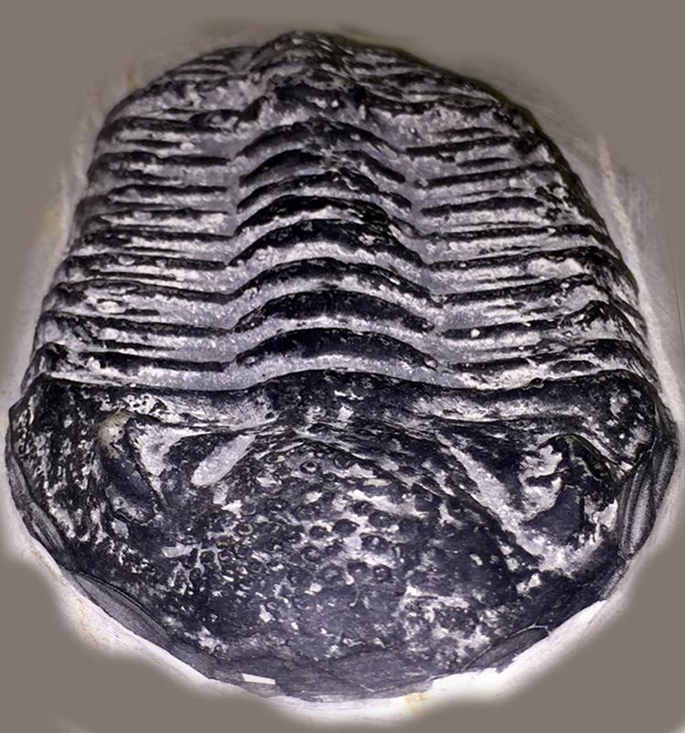

Drotops Megalomanicus (commonly known as Phacops Trilobite) is a hard shelled, segmented creature that inhabited shallow water in warm seas during the Devonian Period (roughly 358.9 - 419.2 million years ago). Phacops has large eyes with fewer lenses that point towards improved optics. The thorax has 12 segments, equipped with facets and the deeply furrowed tail-shield is smaller than its head.

The Trilobite was one of the earliest complex lifeforms and are one of the key signature creatures of the Paleozoic Era. Although they were abundant, Trilobites went extinct before dinosaurs even existed.

This specimen was excavated from the southwest pre-Sahara region of Erfoud Morocco, Africa and is:

* 1 pound 5.4 ounces
* 6 inches long
* 4-1/2 inches wide
* 1 ½ inches thick